**Level 4 - EXPERT**

# Diagonal Lashing

Start with a single Timber Hitch around both poles. Wrap three or four turns around the two poles in one axis followed by three or four turns in the other axis. Tighten the lashing by surrounding it with three or four frapping turns. Finish with a Clove Hitch.

**Use:** The Diagonal Lashing Knot is used to lash two spars together. Unlike the Square lashing which works for right angle crossings, the diagonal lashing secures poles crossing each other at a variety of angles.

# Shear Lashing

Tie a clove hitch around one pole. Wrap both poles with a simple lashing. Wrap the lashing with a two or three tight frapping turns. Tie off the end with a clove hitch. Spread the poles to make shear legs

**Use:** The Shear Lashing Knot is used to lash the ends of two poles together. The other ends are separated to make a pair of Shear Legs.

# Square Lashing

Start with a Clove Hitch around one pole. Twist short end around long and wrap the rope around both poles, alternately going over and under each pole about three or four turns. Tighten the lashing by surrounding it with three or four frapping turns. Finish with two or three tight half hitches.

**Use:** The Square Lashing Knot is used to bind two poles together. The lashing is designed to be load bearing and can be used to create scaffolding. Although the two poles usually cross each other at 90 degrees, the Square Lashing may be used when the angle between the two poles is as little as 45 degrees, Other uses: a table can be supported by a pair of poles; a fence can be constructed by driving poles into the ground and then joining them with bars attached with Square Lashing Knots; and a raft can be created by lashing bamboo poles across each other.

# Round Lashing

Start with a Clove Hitch around both poles. Wrap six or eight turns around the two poles. Finish with another Clove Hitch. Two Round Lashings can be used to make a longer pole.

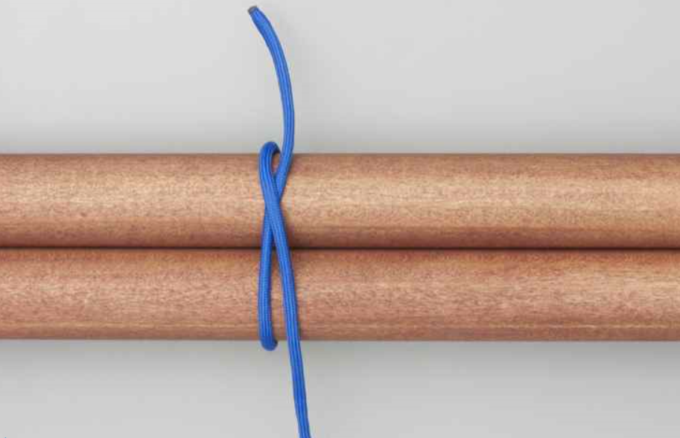 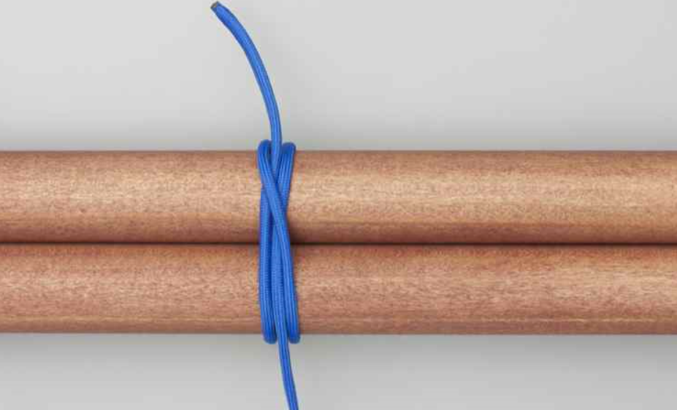

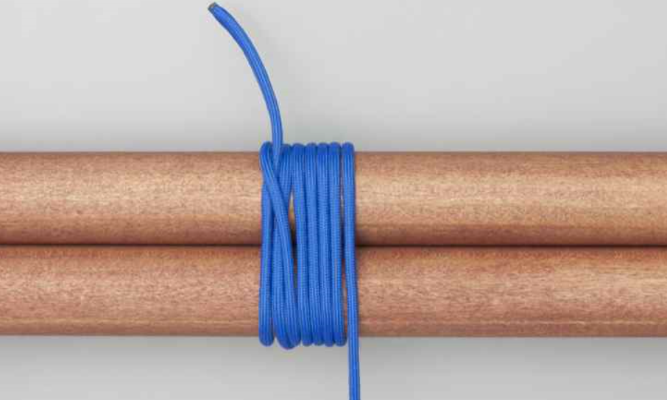 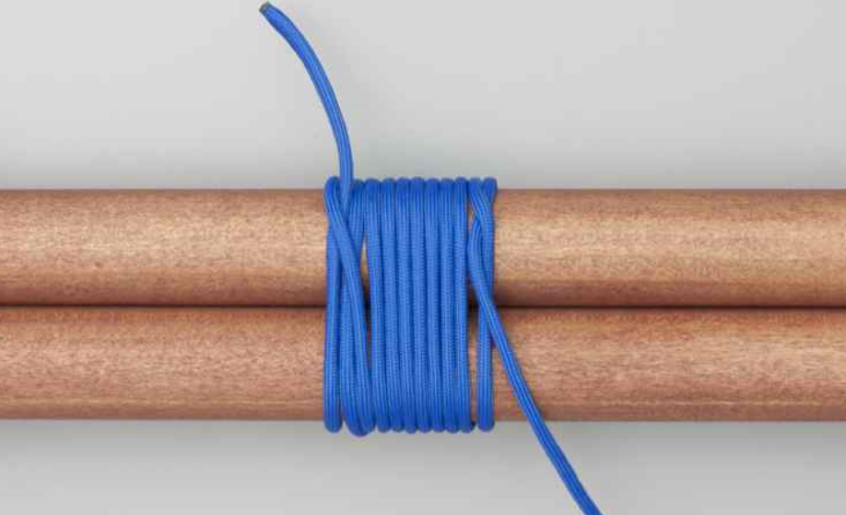

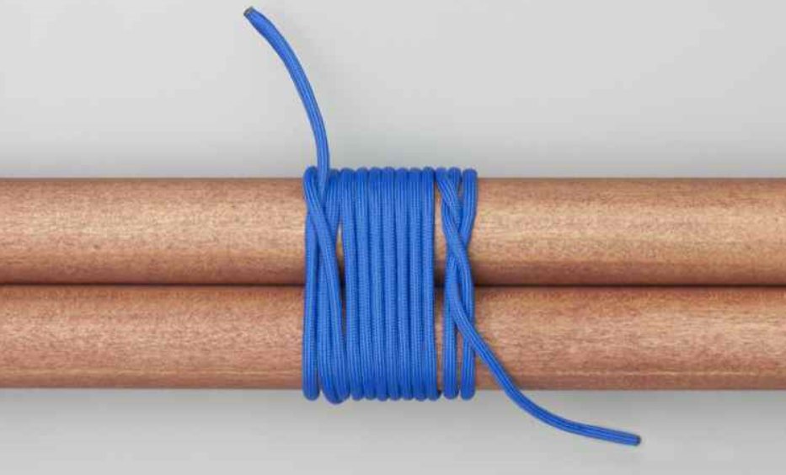 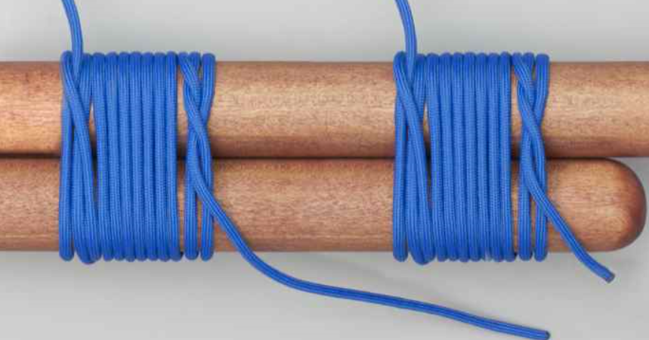

**Use:** The Round Lashing Knot is used to lash two parallel spars together to make a longer one. A common recommendation is to hammer two wedges between the poles, one above and one below the lashing. This tightens the Round Lashing Knot and makes it more secure.