Level 6 – Fun Knots

Cobra Stitch/Knot
The Cobra Stitch/Knot is one of the common lanyard knots. In effect it is a stack of Square Knots tied around a core. Alternatively, the same Half Hitch can be repeated, making a stack of granny knots; the result is a neat spiral. STEPS: Make a loop and tie an overhand knot. Tie a half knot around the loop and tighten. Keeping the same rope in front, tie another half knot and tighten. Keep repeating. Leave the last several knots loose (only two shown here). Tuck the ends inside the loose knots. Tighten the loose half knots and trim the ends off.
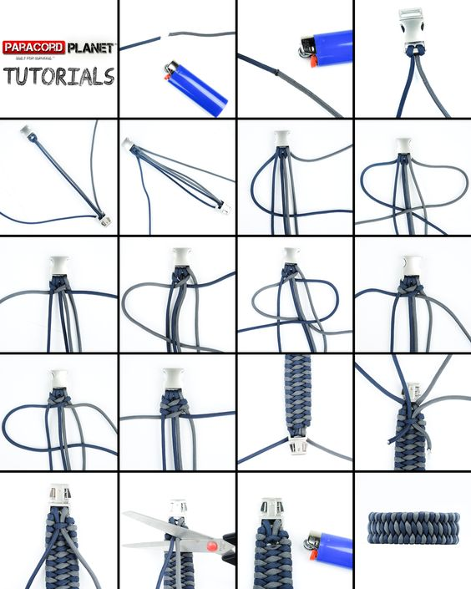

Monkey Fist
A monkey’s fist or monkey paw is a knot that is tied at the end of a rope to serve as a weight. It originated as a heaving line knot on sailing ships. It is so named as it resembles a monkey’s fist or paw. The main purpose of the knot is to serve as a weight at the end of a rope. It can be thrown simply that way. To tie a Monkey Fist, wrap three turns around your fingers (or similar). Pass the end through the middle. Make three more turns around the first ones. Pass the end through the middle. Make three more turns locking the previous turns and remove fingers. Tie a knot in the end and tuck it into the center. Then tighten every turn.
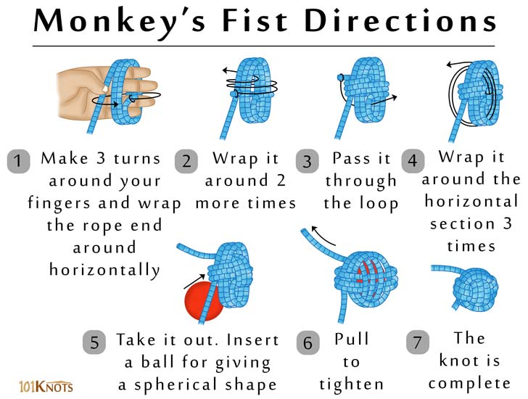

Tips
- Instead of creating the sides with 3 strands each, you can make them so as to possess 4 strands each.
- It would be a good idea to create the knot loose, insert the ball and tighten it around the object, pulling, at a time, one loop taut.
- For a smaller knot, you can use a marble as the core. However, you can do the mini version without the marble just by placing the rope between your fingers and tightening appropriately.

Turk’s Head (Woggle)

The Turk’s Head is essentially a long continuous braid. The interwoven knot owes its name to the resemblance of the turbans wore by Turks, however in Scouts it is known as a “Woggle” and can be tied using 2 or more braids. To tie the Turk’s Head, wrap the line around your hand or similar, overlapping to start the braiding. On the third pass, braid the end and the loops together. Rotate the braid to keep it in view and continue braiding. Then continue braiding by following the rope around the same path for all three turns. Finish by tucking the ends in.

