**Level 1 - NOVICE**

# Square (Reef) Knot

The square knot can join 2 ropes of the same size. It is the first knot we learn to make with our shoelaces. It looks like a bow and is hugely unreliable. It is intended to be a binding knot and, tied in the right material against a curved surface, the first Half Knot may bind – but it cannot be trusted. It helps to secure a line or rope around an object. It creates unique designs of jewelry.

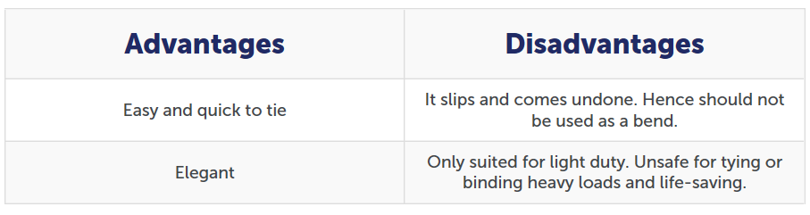

# Figure 8 Knot

The figure 8 knot provides a quick and convenient stopper knot to prevent a line sliding out of sight, e.g., up inside the mast. Its virtue is that, even after it has been jammed tightly against a block, it doesn’t bind; it can be undone easily. This virtue is also, occasionally, a vice. The Figure 8 Knot can fall undone and then has to be retied.

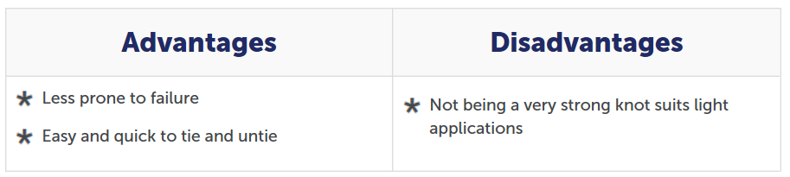

**Sheet Bend**

The Sheet Bend is recommended for joining two ropes of unequal size. The thicker rope must be used for the simple bight as shown. However, it works equally well if the ropes are of the same size. How to tie Sheet Bend : Form a bight in the thicker rope (blue) and hold it in one hand. Pass the thinner rope (red) through the bight and behind the (blue) tail and standing ends in that order. Finally, tuck the smaller rope under itself to finish the knot.

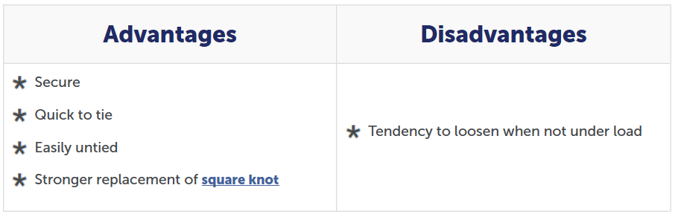

# Slip Knot

The slip knot forms an adjustable loop or noose at the end or middle of a rope. You can place the loop around a support and then tighten the knot by sliding it. This makes it simple attaching a line to a bar or post. There are various ways of tying this knot, but the version of the slip knot shown in the picture below is very quick and easy. It utilizes the same principle applied in tying a [uni knot](http://www.101knots.com/uni-knot.html) albeit with less number of turns around the double line.

## Tips

1. You can make it with just a single wrap as shown in the below video.

## Uses

1. Securing restraints and loads on trailers.

2. Securing horses and other animals to poles.

3. Tying plastic bags, ribbons, rope tree swings, slings, etc.