**Level 3 - ADVANCED**

# Clove Hitch

It is considered one of the most important knots alongside the sheet bend and bowline. Also known as a double hitch, it is simply 2 back to back half hitches around a cylindrical object such as a tree, ax or a post. It causes an efficiency loss of approximately 40%.

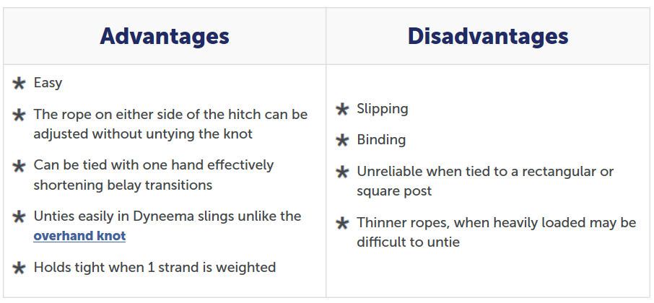

# Timber Hitch

The timber hitch is used to secure a rope round a post or any cylindrical object. It is also known as Bowyer’s Knot owing to its use in attaching the end of the bowstring to a longbow.

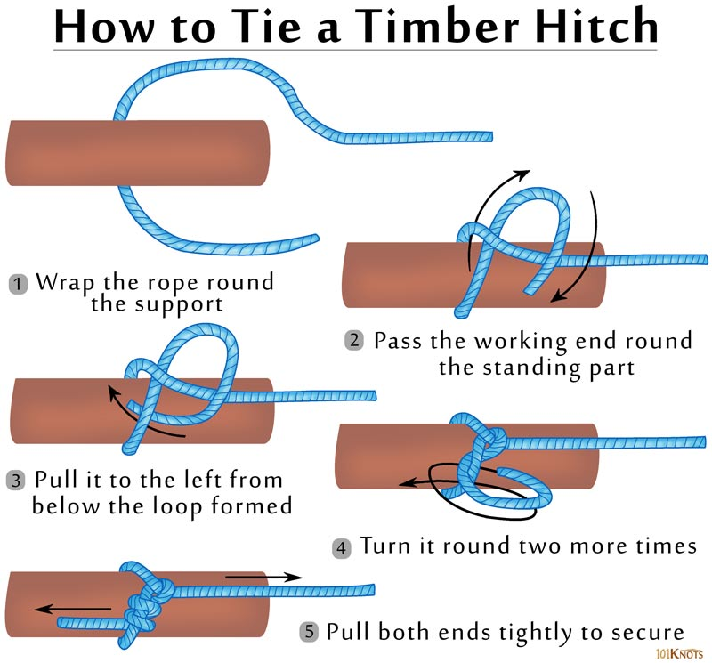

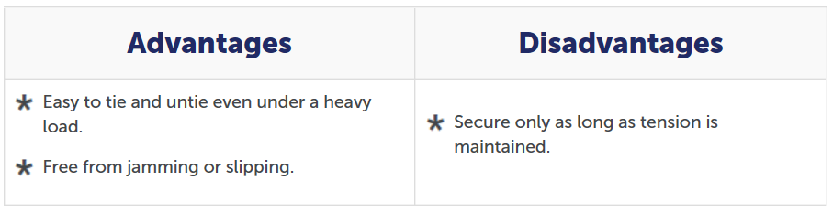

# Bowline Knot

The bowline (pronunciation “boh-lin”) is a knot that can itself be tied at the middle of a rope making a fixed, secure loop at the end of the line. It has many uses, e.g., to fasten a mooring line to a ring or a post. Under load, it does not slip or bind. With no load it can be untied easily. A close up of a necklace

