**Level 5 – Climbing Merit Badge**

# Figure 8 on a Bight

For this, the rope is doubled into a bight followed by tying the Figure 8 knot. It is one of the ways of creating a figure 8 loop apart from the Figure 8 Follow Through. The versatile knot helps in connecting a rope to a carabiner or climbing harness.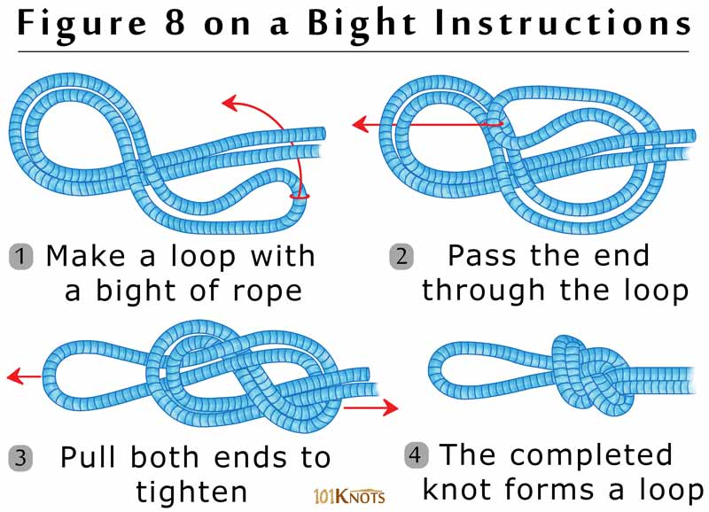

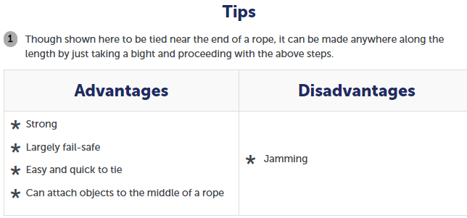

# Double Fisherman’s Knot

The double fisherman’s knot uses two [double overhand knots](http://www.101knots.com/double-overhand-knot.html) in their strangle knot form, one tied around the standing part of the other. It can also be tied with the ends of a single rope to make a loop with it. It is used in creating a cordelette to assist rock climbers. To tie the Double Fisherman’s Knot, overlap the two ends. Wrap one end around both ropes two full turns. Then pass this end back through these turns and pull tight. Next pass the other end two full turns around both ropes. Pass this end back through and pull tight. Pull on both ropes to tighten the two knots against each other.

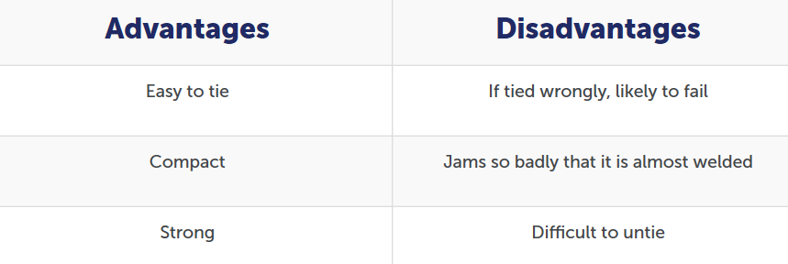

# Figure 8 Follow-Through

It secures the climbing rope to a harness thereby protecting the climber from an accidental fall. This knot allows the simple and reliable Figure 8 loop to be tied to a ring, a carabiner, or your own harness. It is reasonably easy to remember, tie, and check. To tie the Figure 8 Follow-Through, start by tying a loose Figure 8 knot. Pass the tail around the attachment point. Follow the original Figure 8 around the entire knot in reverse. Exit beside the standing end to complete a two stranded Figure 8 knot.

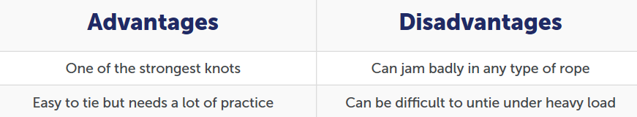

# Safety (Backup) Knot

Climbers often add a “backup knot” to their primary knot for additional security and a safety knot makes sense in a lot of situations involving ropes and knots. The purpose of the safety knot is to avoid the primary knot from untying itself. Although it does use up some rope and is bulky, it is unlikely to work loose, making your primary knot pretty much fail-safe.

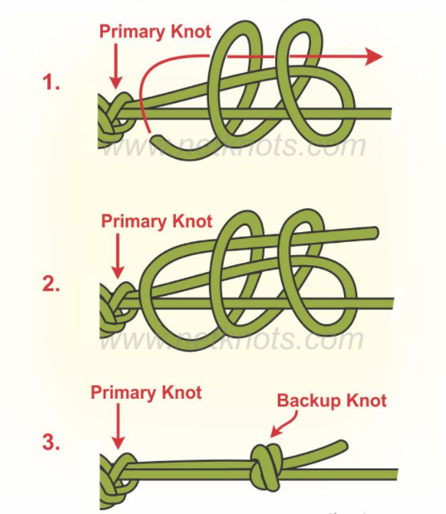

## Safety Knot Tying Instructions

* Wrap the free end twice around the standing rope and the working part of the free end, working back toward the primary knot.
* Feed the free end back through the loops just made.
* Pull free end to tighten backup knot down onto standing line.

# Water Knot

The water knot that essentially uses two [overhand knots](http://www.101knots.com/overhand-knot.html) is also known by the names ring bend, grass knot, tape knot and overhand follow through. To tie a Water Knot, tie a loose overhand knot in the end of the strap. Thread the other strap in the reverse direction following the exact path of the first overhand knot. Pull the knot tight.

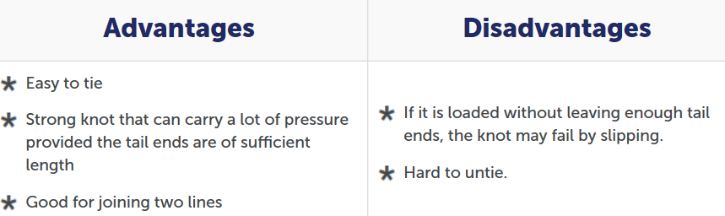

## Tips

1. You should arrange the knot neatly and pull it tight for perfect tying.
2. For additional security, you can back it up by tying each end in a [double overhand knot](http://www.101knots.com/double-overhand-knot.html) around the other standing part.