**Level 7 – Other Knots**

# Carrick Bend

The Carrick bend is a powerful knot to join two heavy ropes, hawsers or cables that are tough to bend. It’s no jamming nature makes it a favorite to hold up massive loads, even under wet or oily conditions. The curvy symmetric form of the knot makes it appealing for decorative purposes too like making mats, wall hangings, rope trivets and coasters. Ashley terms it as a nearly perfect bend.

|  |  |  |
| --- | --- | --- |
| Appearance | Capsized Capsized Carrick Bend | Seized Seized Carrick Bend |
| **Structure** | Bulky and stable due to tightening of the knot. | Ends are seized for a flatter version. |
| **Shape** | Differs from original. | Retains original shape. |
| **Grip** | May slip if capsized naturally. | Secure. |
| **Jamming** | Weave should be loose, else difficult to untie. | Easy to untie. |
| **Uses** | 1. Firmly secures heavy loads if preset carefully with long tag ends. 2. Good for making climbing nets | 1. Prevents knot collapse on extremely long ropes. 2. Suitable for passing through capstans or winches |

# Constrictor Knot

The constrictor knot, also known as the Gunner’s knot, is a strong knot used for binding and whipping purposes. It is very difficult to untie and might need the rope to be cut for release.

|  |  |
| --- | --- |
| Advantages | Disadvantages |
| Useful when the rope needs to be passed round the object that is to be tied. | Cannot be tied to a flat surface. Needs a curved surface for proper function. |
| Extremely secure | Jamming release |

# Fisherman’s Knot

Fisherman’s knot, also known as English knot, consists of two [overhand knots](http://www.101knots.com/overhand-knot.html) each one tied around the standing part of the other one. Though it is mainly used as a bend to join two lines, it can be easily used to connect the ends of a single length of rope to form a loop. The beauty of the knot lies in its symmetry.

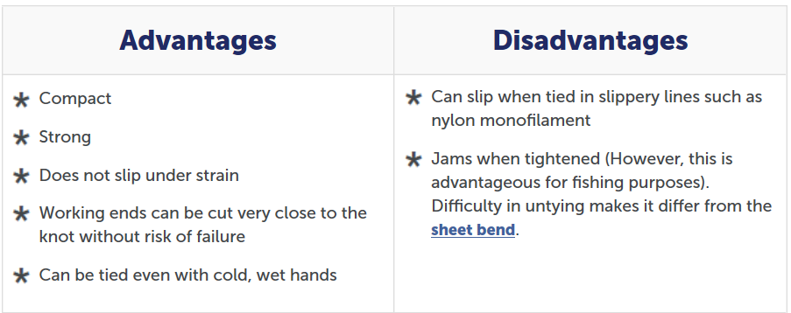

# Midshipman’s Hitch

If you need an adjustable loop at the end of a rope, the midshipman’s hitch would be a good choice. You can slide the knot up and down the standing part varying the size of the loop, but when a load is applied at the longer rope end, the knot holds securely. It is referred to in The Ashley Book of Knots.

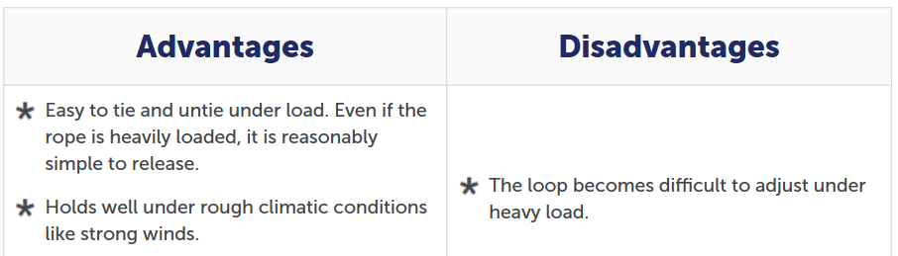

# Adjustable Grip Hitch

The Adjustable Grip Hitch is a Friction Knot that is readily adjusted when not loaded. It is useful for tensioning a line such as a tent ridgeline or a guy-line. When the knot is adjusted, by sliding it along the standing end, it may require tightening with a pull on the leg that forms the knot. It should be avoided for critical applications such as climbing since it may slip when shock loaded.

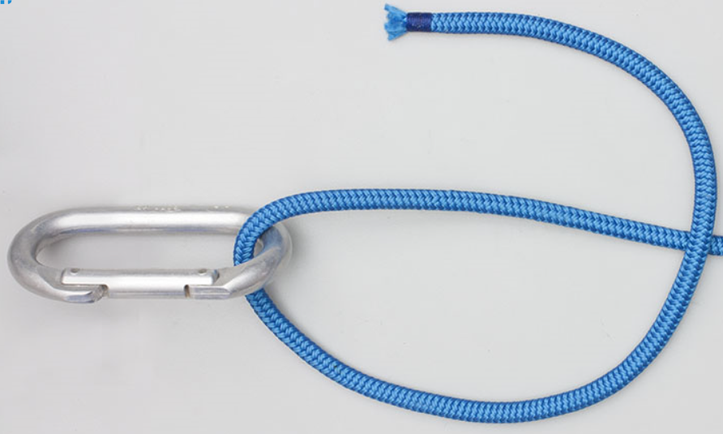 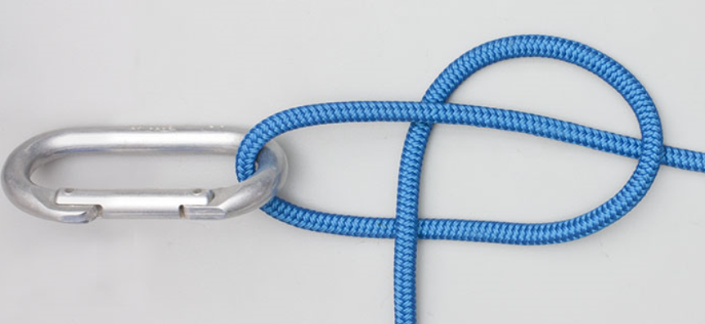

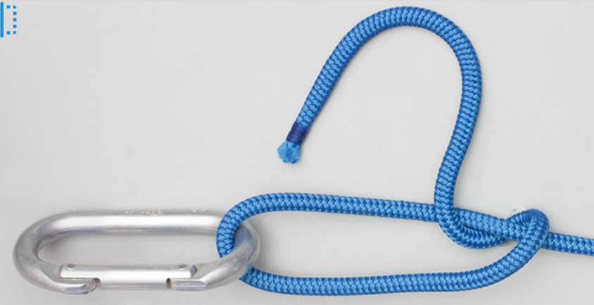 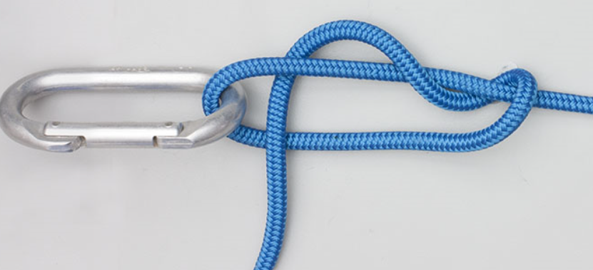

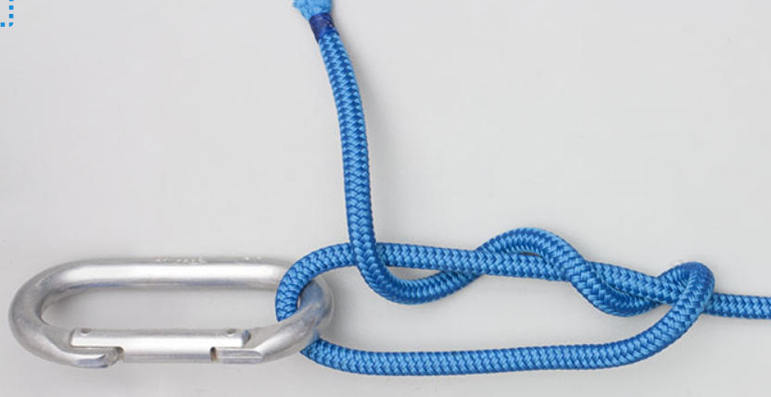 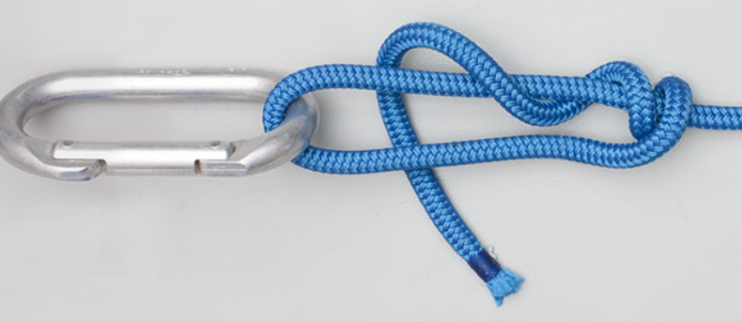

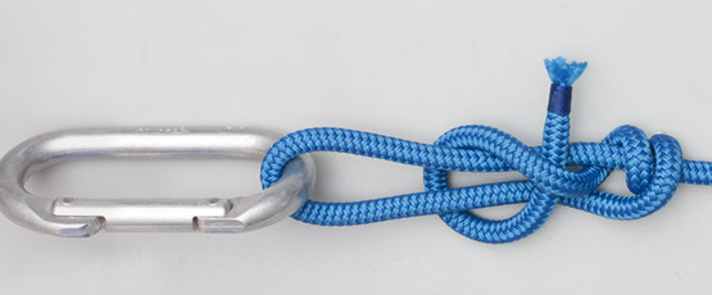 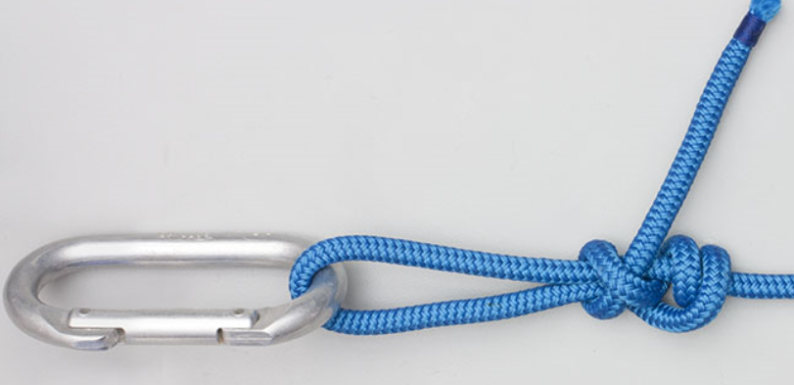

# Alpine Butterfly

The Alpine Butterfly Loop is useful anytime a secure loop is required in the middle of a rope. A good example is when a line of hikers wish to hook on along the length of a shared rope or as a possible option for the first part of a [Trucker’s Hitch](https://www.animatedknots.com/truckers-hitch-knot). Also, if a length of rope is damaged, it is a wonderful way to isolate the damaged section so that the rope may still be used. Counted among the most secure knots, it can be done in just three steps, as instructed below:

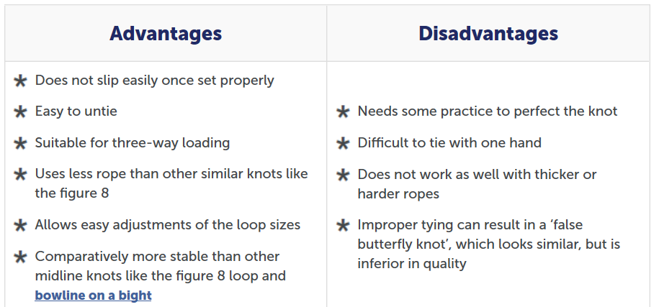

# Mooring Hitch

The mooring hitch is a simple knot that can be released quickly with just a pull at the tag end. It is more secure than the slippery hitch knot and is used in temporarily mooring boats. It can be tied around a tree, pole or anywhere along the length of another rope.

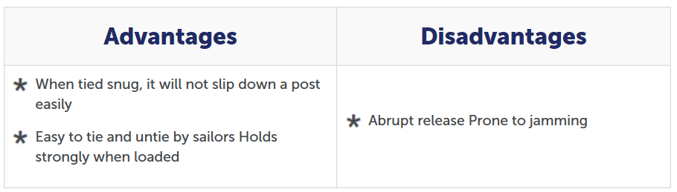

Bowline on a Bight

Bowline on a bight creates a secure loop in the middle of a length of rope. It is a variation of the [bowline knot](http://www.101knots.com/bowline-knot.html) that looks similar but is made with a single strand of rope. This knot is convenient when a dependable loop is required but neither end is available. To tie a Bowline on a Bight, use the middle of a piece of rope and form a bight. Make a loop and pass the end of the bight through it. Open up the bight and bring it around the entire knot until it encircles both standing ends. Tighten to complete the knot.

Marlinespike Hitch

Also known as the lever hitch, the marlinspike is a temporary knot that attaches a rod to a rope making a handle in the process. A small modification serves as an alternative way to tie the [bowline knot](http://www.101knots.com/bowline-knot.html). It provides an excellent way to make a rope ladder. It ties quickly and is easy to release. It does not jam. To tie a Marlinespike Hitch, make a loop and through it tuck a bight of the standing end. Place the loop over the pole and tighten it. With a second rope, tie the same knot at the other end of the pole. Repeat to make a step ladder.

Trucker’s Hitch

The Trucker’s Hitch (Power Cinch Knot, Lorry Knot, Haymaker’s Hitch, Harvester’s Hitch) has the distinctive feature of providing a mechanical advantage when being tightened. The variety of names for this hitch is a tribute to its widespread use. It is a valuable knot – particularly for securing loads or tarpaulins. To tie a Trucker’s Hitch, form a bight in the standing end and use it to tie a Directional Figure 8 Knot. Pass the tail round the hook below and through the Directional Figure 8 Loop and pull tight. Complete the knot with two Half Hitches below the loop.

## Tips

1. Instead of the carabiner it can be any cylindrical support like a tree trunk, etc.
2. It can be finished off with a [**taut line hitch**](http://www.101knots.com/taut-line-hitch.html). Less prone to slipping than the latter.
3. If you are pulling at the working end, it gives a mechanical advantage of 2:1. It is because the common variations of the hitch use the loop in the standing part and the anchor point as makeshift pulleys.

Tumble Hitch

This quick release knot is of the draw loop type and can temporarily secure a load that is to be released cleanly and easily. It involves 3 bights of the same rope each of which successively lock the previous one. To tie a Tumble Hitch, hold an initial bight of the rope against the pole. Place a second bight behind the pole and through the initial bight. Pass the tail around the Standing End. Then tuck a bight through the second one. Tighten to secure the knot and take the load. Pull the tail to release.

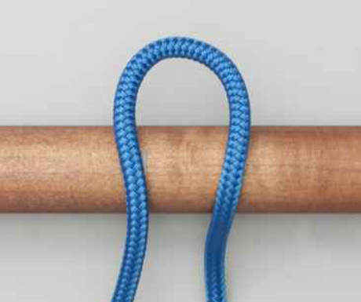 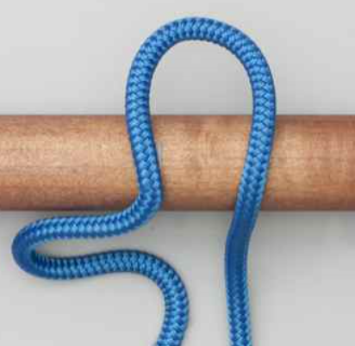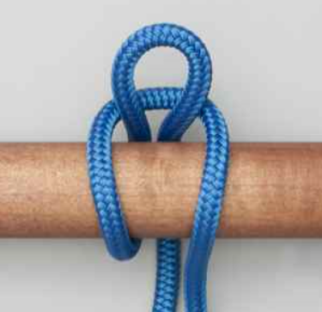 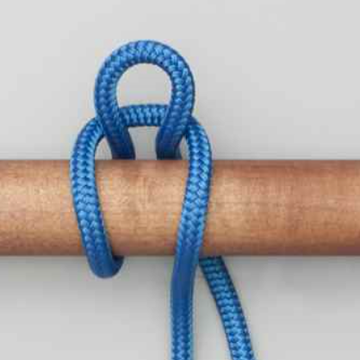 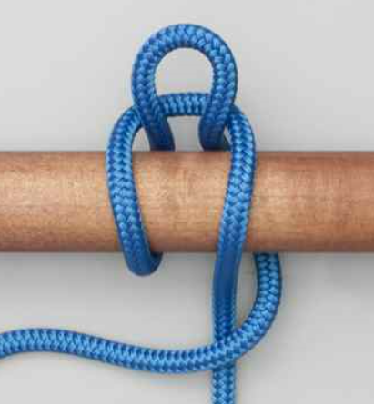 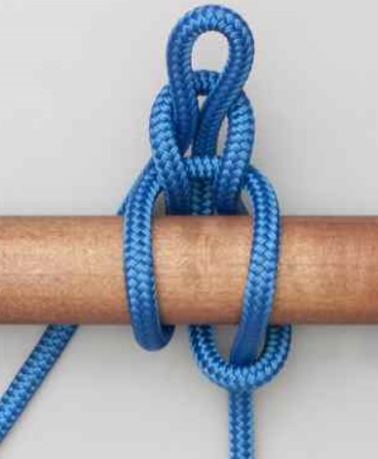

**Advantages:**

The Tumble Hitch is stable and jam-proof even with heavy loads. The design of the hitch transfers the load first to an intermediate bight and then to the final locking bight. This limits the load on the locking bight and avoids jamming.

**Tying it:** The standing part remains passive while the knot is being tied. The user can hold up the first bight, and then transfer his grip to the second and third bight in succession. When complete, the hitch should be carefully tightened.